**Consume Microsoft Graph API Using a PnP Graph from SPFx Webpart**

Follow Lab 15

1. Create a new webpart in the same solution

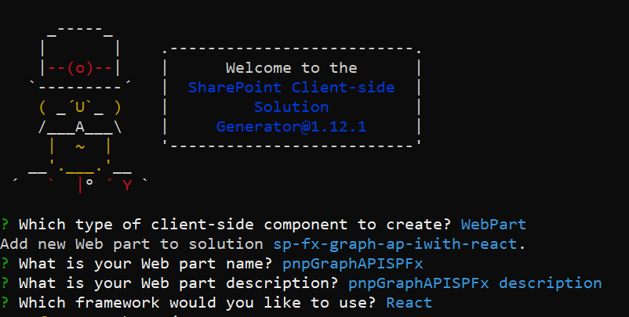

After successful project creation, let me install the required libraries via NPM.

npm install @pnp/graph

Open IPnpGraphApispFxProps.ts

import { WebPartContext } from '@microsoft/sp-webpart-base';

export interface IPnpGraphApispFxProps {

  description: string;

  context: WebPartContext;

}

Create IPnpGraphApispFxState.ts and open

export interface IPnpGraphApispFxState {

    userlist:IUserItem[];

  }

  export interface IUserItem {

    displayName: string;

    email:string;

  }

Open PnpGraphApispFx.tsx

import { IPnpGraphApispFxState, IUserItem } from './IPnpGraphApispFxState';

import { graph } from '@pnp/graph';

import '@pnp/graph/Users';

import {

  PrimaryButton,

  TextField,

  Label,

  DetailsList,

  DetailsListLayoutMode,

  CheckboxVisibility,

  SelectionMode

} from 'office-ui-fabric-react';

let _listItemColumns = [

  {

    key: 'displayName',

    name: 'Display Name',

    fieldName: 'displayName',

    minWidth: 100,

    maxWidth: 200,

    isResizable: true

  },

  {

    key: 'email',

    name: 'Email',

    fieldName: 'email',

    minWidth: 50,

    maxWidth: 200,

    isResizable: true

  }];

Update the class

export default class PnpGraphApispFx extends React.Component<IPnpGraphApispFxProps, IPnpGraphApispFxState, {}> {

  constructor(props: IPnpGraphApispFxProps, state: IPnpGraphApispFxState) {

    super(props);

    graph.setup({

      spfxContext: this.props.context

    });

    this.state = {

      userlist: []

    };

  }

  public componentDidMount() {

    var _userlist: Array<IUserItem> = new Array<IUserItem>();

    graph.users.get().then(users => {

      users.map(value => {

        _userlist.push({

          displayName: value.displayName,

          email: value.userPrincipalName

        });

      });

      this.setState({ userlist: _userlist });

    }).catch(error => {

      console.log(JSON.stringify(error));

    });

  }

  public render(): React.ReactElement<IPnpGraphApispFxProps> {

    return (

      <div className={styles.pnpGraphApispFx}>

        <div className={styles.container}>

          <div className={styles.row}>

            <div className={styles.column}>

              <DetailsList

                items={this.state.userlist}

                columns={_listItemColumns}

                setKey='set'

                checkboxVisibility={CheckboxVisibility.hidden}

                selectionMode={SelectionMode.none}

                layoutMode={DetailsListLayoutMode.fixedColumns}

                compact={true}

              />

            </div>

          </div>

        </div>

      </div>

    );

  }

}

* Then go to PnpGraphApispFxWebPart.tss file
* Add the context next to the description in render method

description: this.properties.description,

**context: this.context**